1. **A screenshot of a computer

   Description automatically generatedLess file1: less command is used to display the data inside the terminal**
2. **Less -p ‘linux’ file1:**

*-p pattern : it tells less to start at the first occurrence of pattern in the file*

1. **Less -N file1:**

**This command gives file content with line number**

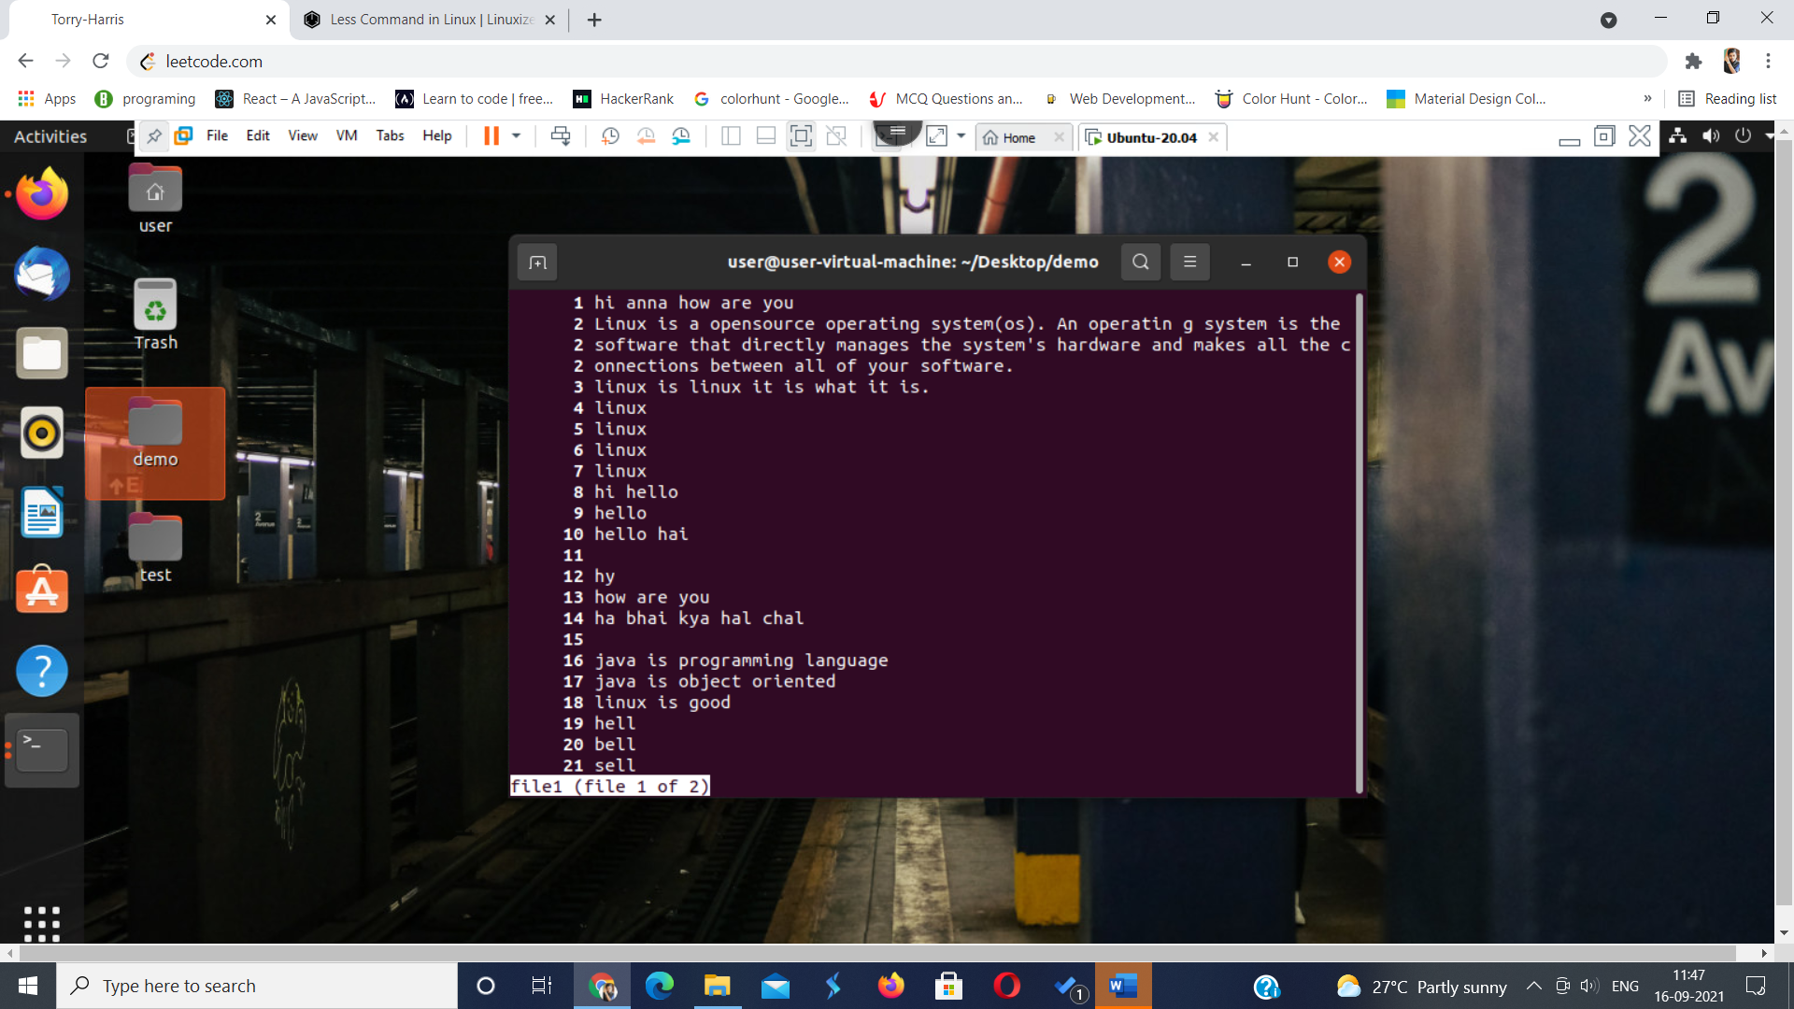

1. **Vim: vim is a simple text editor**

**Vim <filename> if the file doesn’t exist it will create a new file**

1. ***i****: Inserts text before current cursor location.*
2. ***I****: Inserts text at beginning of current line.*
3. ***a****: Inserts text after current cursor location.*
4. ***A****: Inserts text at end of current line.*
5. ***o****: Creates a new line for text entry below cursor location.*
6. ***O****: Creates a new line for text entry above cursor location.*
7. ***r****: Replace single character under the cursor with the next character typed.*
8. ***R****: Replaces text from the cursor to right.*
9. ***s****: Replaces single character under the cursor with any number of characters.*
10. ***S****:Replaces entire line.*
11. **A screenshot of a computer

    Description automatically generated**
12. **To save the file later press esc to enter the command mode**

**Type :wq w means write and q means quit -> which will save and quit your file if this is the new file u need to specify the filename after wq**

1. **Use k to move around lines**
2. **Use w to move around words**

**There are many other options to replace single char r and to replace full line use R**

**! ->> this is used to quit the vim(come out from the vim) after q or wq**

**To rename the file use w <filename>**

1. **Head command:**

**Head command is used to print the top 10 lines of the file by default it is 10**

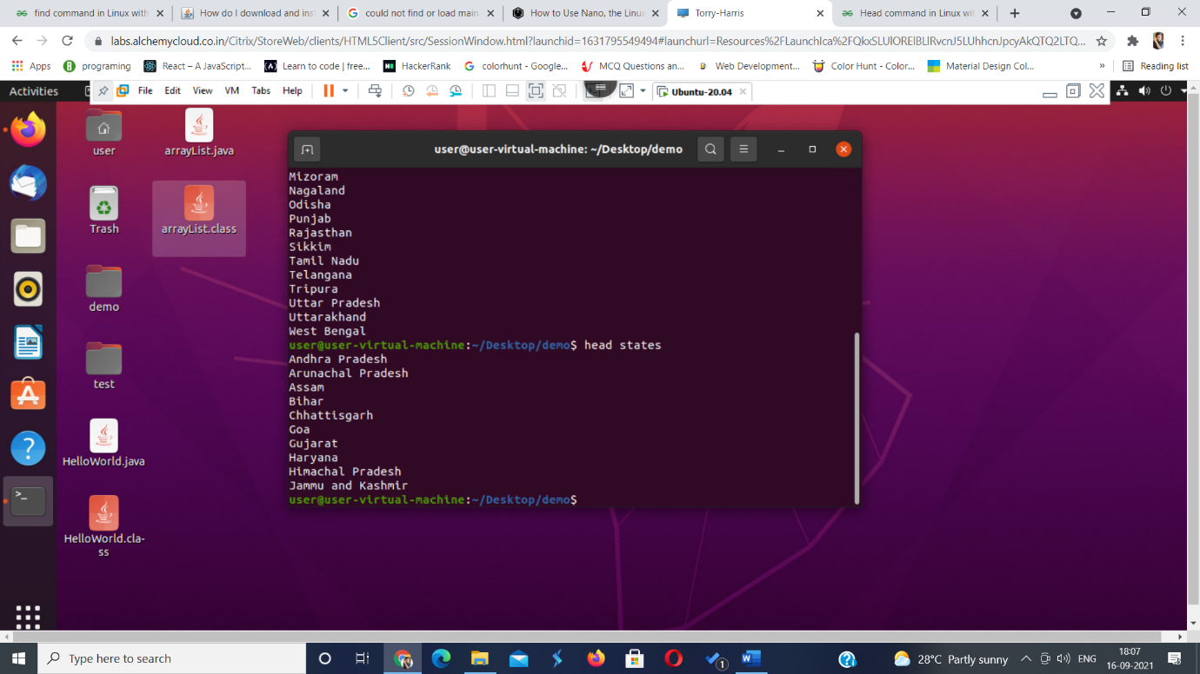

**$ head -c 6 state.txt**

**Prints the first 6 char of the first line**

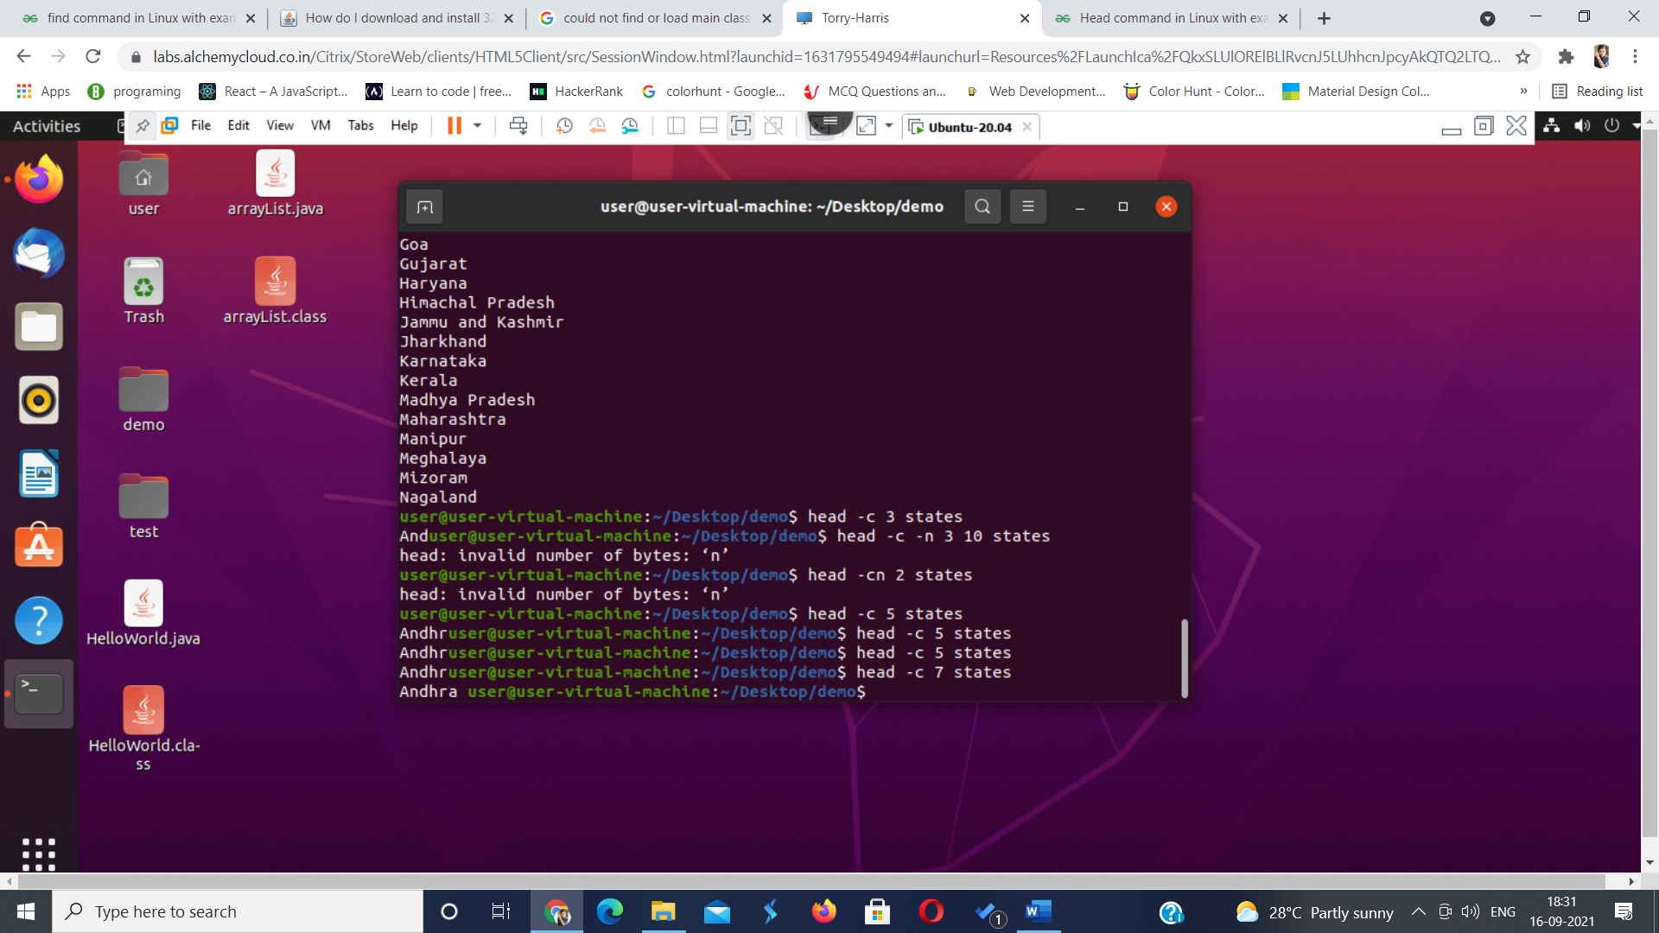

**$ head -q state.txt capital.txt**

